**Student**

login()

logout()

requestclass()

viewtimetable()

username:String

password :string

**Admin**

login()

logout()

setclass()

deleteclass()

createaccount()

Username: String

password : String

**Teacher**

login()

logout()

viewclass()

cancelclass()

Username: String

Password: String

**Website**

login()

about()

Contact()

createaccount()

services()

**Createaccount**

createaccount()

Name: string

Role: string

Address: string

Phonenumber: integer

Instrument type: string

Age: integer

**Basic Class Diagram:**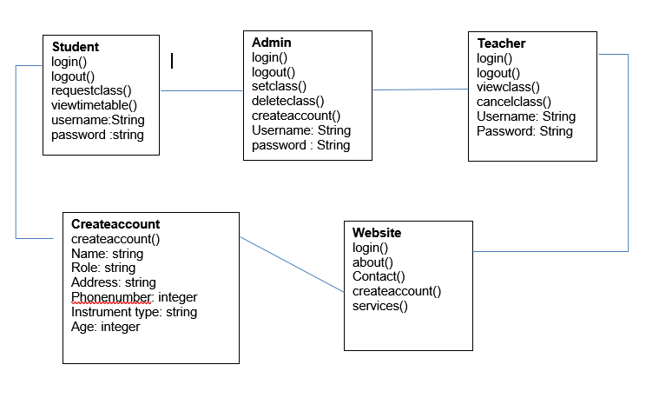

**Advanced Class Diagram:**

**Version 1.0:**

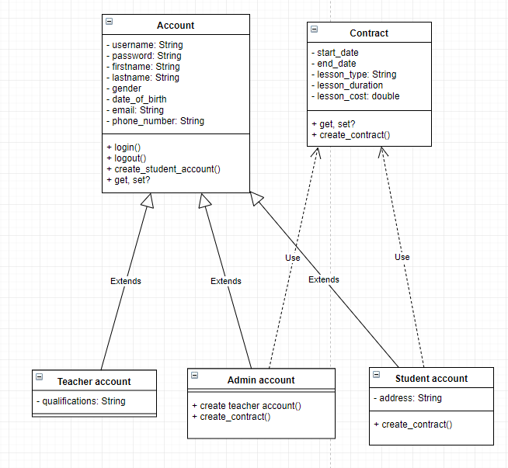

**Version 1.1:**

